COLLECTIVE BARGAINING AGREEMENT

Between

The UConn Health
Board of Directors

And

The University of Connecticut Health Center Chapter
of the American Association of University Professors

July 1, 2021 - June 30, 2024

Table of Contents
ARTICLE 1 RECOGNITION 3
ARTICLE 2 BOARD PREROGATIVES 3
ARTICLE 3 AAUP RIGHTS AND SECURITY 4
ARTICLE 4 GOVERNANCE 6
ARTICLE 5 MAINTENANCE OF PROCEDURES, PRACTICES AND POLICIES 7
ARTICLE 6 NONDISCRIMINATION 8

ARTICLE 7 DISCIPLINE…………………………………………………………………… 8

ARTICLE 8 MEDICAL STAFF PEER REVIEW …………………………………………..11

ARTICLE 9 CONTRACTUAL GRIEVANCE PROCEDURE …………………………….11

ARTICLE 10 JOINT TASK FORCES ……………………………………………………….13
ARTICLE 11 LABOR MANAGEMENT COMMITTEES …………………………….. ….14
ARTICLE 12 JOB SECURITY ……………………………………………………………….14
ARTICLE 13 COMPENSATION ………………………………………. . . ………………...16
ARTICLE 14 FACULTY COMPENSATION DISTRIBUTIONS …………………………17
ARTICLE 15 PARKING ………………………………………………………………………28
ARTICLE 16 PROFESSIONAL DEVELOPMENT ………………………………………...29
ARTICLE 17 MULTI-YEAR APPOINTMENTS …………………………………………..31
ARTICLE 18 FTE FOR UNION LEADERSHIP …………………………………………...35
ARTICLE 19 CLINICAL EFFICIENCY AND BEST PRACTICES ……………………..35
ARTICLE 20 FACULTY ASSISTANCE PROGRAMS …………………………………. .36
ARTICLE 21 HOLIDAY COMPENSATION ………………………………………………36
ARTICLE 22 FACULTY EDUCATIONAL MATERIALS ……………………………….36
ARTICLE 23 FACULTY FAMILY MEDICAL LEAVE…………………………………..37
ARTICLE 24 LONG-TERM DISABILITY INSURANCE………………………………...38
ARTICLE 25 CURRENT MEMORANDUMS OF AGREEMENT………………………..39
ARTICLE 26 SAVINGS CLAUSE…………………………………………………………...40
ARTICLE 27 DURATION …………………………………………………………..40
ATTACHMENTS ……………………………………………………………………………..41

ARTICLE I

RECOGNITION

1.1 The Board of Directors of UConn Health (hereinafter "Board") recognizes the University of
Connecticut Health Center Chapter of the American Association of University Professors
(hereinafter "Union" or "AAUP") as the exclusive bargaining representative for all faculty at UConn Health who are full time or who work a full-time equivalent equal to or greater than twenty percent (0.2 FTE) and who are not excluded in the following paragraph, for the purpose of negotiating with respect to wages, hours and other conditions of employment. Hereinafter for the purposes of collective bargaining, faculty who are not excluded pursuant to this Article are referred to as "faculty," or "members," or "members of the bargaining unit."
Members of the faculty who hold the following positions are excluded from the bargaining unit: Deans, Senior Associate Deans, Associate Deans, Assistant Deans, the Chief of Medical Staff, Chief Medical Officer, Chief Quality Officer , the Faculty Representative to the UCH Board of Directors, the Special Assistant to the Vice President for Health Affairs, Department Chairs, Dental School Division Chairs, Type II Center Directors, the Director of Health Affairs Policy and Planning, and retired re-employed employees.
1.2 The parties agree that the list of excluded faculty positions may change from time to time. The exclusion of new position titles from the faculty unit shall be preceded by discussion with the AAUP. Any impasse in this area shall be submitted to the State Labor Relations Board for resolution.

ARTICLE 2

BOARD PREROGATIVES

2.1 It is recognized that the Board has and will, consistent with the By-Laws of the University of Connecticut Board of Trustees, continue to retain, whether exercised or not, the sole right, responsibility or prerogative to make rules for the governance of UConn Health and shall determine the general policies of UConn Health , including those concerning the admission of students and the establishment of schools, centers, divisions, and departments, and to determine the mission of UConn Health and the methods and means necessary to fulfill that mission.
The Board shall determine and make rules for all patient care activities; the care, maintenance, and operations of buildings, land, apparatus, and other property used for school programs and courses; staffing requirements; the calendar; and the establishment of reasonable work rules.

2.2 The Board shall have sole jurisdiction over the selection, appointment, assignment of duties and hours of work, amount of compensation, sick leave, vacation, leaves of absence, termination of service, qualifications, rank, and status of the individual members of the faculty of UConn Health; over standards of performance, discipline, order and efficiency; as well as the decision to reward, promote, demote, suspend, discipline or discharge unit members for just cause, to terminate unit members for lack of work or other legitimate reason, to establish contracts or subcontracts for services, positions or programs; UConn Health operations, and to determine whether the whole or any part of the operations shall continue except as specifically limited by the terms and provisions of this Agreement.
2.3 These rights, responsibilities, and prerogatives are not subject to delegation to the AAUP in full or in part except that the same shall not be exercised in a manner inconsistent with or in violation of any of the specific terms and provisions of this Agreement. No action taken by the Board with respect to such rights, responsibilities, and prerogatives other than the specific provisions contained in this Agreement shall be subject to the grievance provisions of this contract.

ARTICLE 3

AAUP RIGHTS AND SECURITY

3.1 During the life of this Agreement a member of the bargaining unit shall retain the freedom to decide whether or not to become or remain a member of the Union.
3.2 Within thirty (30) days of approval of the contract by the Legislature and as instructed by the Union during the life of the contract, the University shall deduct AAUP dues biweekly from the gross paycheck of each member.
3.3 The amount of dues or agency service fee deducted under this article shall be remitted to the Union as soon as practicable after the pay period of the faculty member for whom any such deduction is made. No payroll deduction of dues or agency service fee shall be made during a payroll period in which earnings are insufficient to cover the amount of deduction nor shall such deductions be made from subsequent payrolls to cover the period in question. The Union shall be notified when such a situation exists.
3.4 AAUP shall provide to UConn Health’s payroll office, biweekly any changes to members’ authorization to deduct dues in a format mutually agreed upon by the parties. By providing such list, AAUP certifies that each employee has knowingly and willfully consented to the payroll deduction. Within 10 business days of receipt, UCHC-AAUP shall notify UConn Health’s payroll office, in writing, of any revocations and the effective date of the same.

3.5 Should a bargaining unit member approach UConn Health or its agents seeking to terminate or modify their contractual relationship with AAUP, that bargaining unit member will be directed to communicate such intent directly with AAUP. In such case, UConn Health may notify the employee of its obligation to comply with this Article, including Section 3.3 above. If UConn Health is informed of a dispute between the bargaining unit member and AAUP concerning the obligation to withhold dues, it may invoke Section 3.6.
3.6 Upon request from UConn Health, AAUP shall provide legally sufficient proof of the authorization to collect dues through the payroll deduction to UConn Health for any employee who disputes said authorization as notified in section 3.5. If the requested proof of authorization is not provided within seven (7) calendar days of the request, UConn Health will cease withholding union dues for that employee not later than the first day of the following payroll period. UConn Health may request a dues reconciliation when a concern has been raised regarding the accuracy of a deduction or to whom the deductions are applied
3.7 On a monthly basis, the Administration shall provide the Union a list of bargaining unit members that will include name, title, department, FTE and salary.
3.8 The Administration will provide the Union, within a reasonable time frame, any information it requests that is needed for collective bargaining, grievance handling or the administration of the contract.
3.9 The Parties will meet periodically to exchange information and to discuss matters of mutual concern.
3.10 This Agreement shall be made available to bargaining unit members electronically. An electronic version (e.g., pdf) of this Agreement shall be posted on the UConn Health website.

3.11 In accordance with procedures promulgated by the Office of the State Comptroller, UConn Health shall allow for the voluntary payroll deduction of contributions for AAUP’s political action fund. Authorization for such deduction by the employee shall be provided in writing by AAUP to UConn Health’s payroll office consistent with process outlined in 3.3 above. The AAUP will hold UConn Health harmless and indemnify it from any claims, actions or proceedings resulting from this deduction.

3.12 UConn Health assumes no obligation, financial or otherwise, arising out of the provisions of this Article, and the AAUP hereby agrees that it will indemnify and hold UConn Health harmless from any claims, actions or proceedings hereunder. Once the funds are remitted to the AAUP, their disposition thereafter shall be the sole and exclusive responsibility of the Union.

3.13 Once every two weeks, the AAUP shall be provided time during New Employee Orientation conducted by UConn Health to provide information to newly hired faculty.

ARTICLE 4

GOVERNANCE

4.1 Although the AAUP, as the elected bargaining agent, retains the exclusive right to negotiate and reach agreement on terms and conditions of employment for the members of the bargaining unit, and the Board retains its rights, under law, to manage and direct UConn Health, the parties recognize the necessity of a collegial governance system for faculty in areas of academic concern. It is mutually desirable that the collegial system of shared governance be maintained and strengthened so that faculty will have a mechanism and procedure, independent of the collective bargaining process, for making recommendations to appropriate administrative officials and to the Board, for resolving academic matters, through the organizational divisions of the Health Center.
4.2 This article on governance is a statement of intent and policy and is not subject to the Contractual Grievance Procedure.

ARTICLE 5

MAINTENANCE OF PROCEDURES, PRACTICES AND POLICIES

5.1
(a) Maintenance of Procedures and Practices. The Parties agree to maintain for the duration of the contract all procedures and practices for UConn Health not modified by the terms of this Agreement governing appointment, reappointment, non-reappointment, tenure, post tenure review, promotion, dismissal, termination, suspension, award of leaves of absence, grievances, and the determination of workloads as specified by the most current University or School of Medicine or School of Dental Medicine By-Laws.
(b) The Parties agree further that the procedures and practices of UConn Health maintained by Section 5.1 above may be changed only by the Board, consistent with the procedures established in each School's By-laws, or by the University of Connecticut Board of Trustees, in the case of modifications to the University of Connecticut By-Laws.
5.2 Maintenance of Policies. Nothing in this Agreement shall be construed to deny the authority of the Board to establish or change policies through established processes, which may include prior discussion with the AAUP as appropriate.

ARTICLE 6

NONDISCRIMINATION

6.1 The Board and the Union agree that no bargaining unit member shall be discriminated against because of race, color, sex (including pregnancy), age, national origin, ethnicity, marital status, physical disability, intellectual disability, past or present history of mental disability, learning disability, religious creed, ancestry, sexual orientation, transgender status, gender identity or expression, genetic information, veteran status, political belief, political affiliation or membership or non-membership in any labor organization, or any other characteristic protected by law.
6.2 Allegations of discrimination are not subject to the grievance and arbitration provisions of this contract but may be processed by any aggrieved member of the bargaining unit in accordance with the University's internal procedures or by the use of external administrative and judicial processes.

ARTICLE 7

DISCIPLINE

7.1 The Parties wish to encourage open communication between administrators and faculty and agree that whenever possible problems should be resolved informally before these procedures are initiated. The Parties agree that this Article shall not be used to restrain faculty members in the exercise of their academic freedom or their rights as citizens.
The Parties agree that, except for serious misconduct, dismissal should occur only as the final step in a progressive disciplinary system and each instance of misconduct shall be judged solely on its own factual situation.
7.2 Dismissal or discipline which is the result of failure to meet satisfactory standards of job performance or is a result of incompetence shall not fall within the purview of this Article, but shall be dealt with exclusively under the University or appropriate School By-Laws.
7.3 Discipline is defined as one or more of the following actions: written reprimand or warning, suspension without pay, demotion, and/or dismissal.
A. Discipline shall be for just cause including but not limited to such situations as:
1. neglect of assigned responsibilities;
2. insubordination, serious misconduct, or non-compliance with current University of Connecticut or School ByLaws; noncompliance with the Code of Ethics for Public Officials (Chapter 10 of the Connecticut General Statutes), University Code of Conduct or with University, State, or Federal regulations governing research; or with Health Center rules or regulations; or pertaining to faculty practice plans and hospital practice standards;
- the use of fraud, collusion, concealment, or misrepresentation of a fact material to obtaining employment with the Health Center and/or obtaining promotion, tenure, salary increase, or other benefit;
- sexual harassment, harassment, discrimination, retaliation, serious misconduct, or other conduct which impairs the rights of students or other staff members.
- off-duty misconduct or behavior which adversely impacts UConn Health or the University’s operations or reputation.

B. Procedures to be followed for written warnings, reprimands, dismissal, demotion, or suspension without pay.
- The faculty member shall receive in writing a statement from their Department Head, Director, Chair or Division Chair for the School of Dental Medicine of the reasons for the disciplinary action being recommended.
- Within seven (7) calendar days of receiving the written statement (B. 1), an opportunity for a meeting shall be provided to the faculty member with their Department Head, Director, Chair or Division Chair for the School of Dental Medicine or their designee with an AAUP representative present, should the faculty member so desire. This meeting shall be held within seven (7) calendar days of the member's request. The Department Head, Director, Chair or Division Chair of the School of Dental Medicine shall issue a written recommendation of disciplinary action, if any, to the Dean and setting forth the basis of the recommendation within seven (7) calendar days of the meeting.
- Within seven (7) calendar days of receiving the recommendation in 7.3.B.2 above, the faculty member shall have the right to appeal to the appropriate Dean or the Dean’s designee. At such meeting, the faculty member shall have the right to be represented by the AAUP. The Dean or the Dean’s designee shall issue a written decision on the appeal within fifteen (15) calendar days of the meeting. If the faculty member does not appeal the recommendation of discipline, then the Dean shall issue a written decision within seven (7) calendar days of receipt of the recommendation of discipline.
- The decision of the appropriate Dean or the Dean’s designee may be appealed to arbitration on the merits under Article 9 of this Agreement. Warnings, reprimands, and other less severe discipline shall be grievable through steps 9.4 and 9.5 of the grievance procedure but shall not be grievable to arbitration.
C. The faculty member has the right to have an AAUP representative present at an investigatory interview at the request of such faculty member.

D. 1. If the UConn Health , including the Schools of Medicine and Dental Medicine, judges that the grounds for dismissal or discipline require the immediate suspension of the faculty member, the suspension shall be with pay until the meetings described in B.2 and B.3 above have taken place.
2. In the event the discipline involves the loss of or reduction in salary, the salary shall not be withheld until after the arbitration decision or four (4) months from the initiation of the discipline at B.4, whichever is sooner.
E. For cases involving discipline or dismissal for misconduct, the procedures outlined above supersede Section XIV, G, H, I, J and T of the most current edition of the University ByLaw, except as provided for in Article 7, Section F, below.
F. In lieu of utilizing the arbitration procedures set forth in this Article 7, Section B.4 and Article 9.6 (Contractual Grievance Procedure) for discipline or discharge for misconduct, a faculty member, at their own election, may use the appeals procedures set forth in Article XIV, G, H, I, J and T of the most current edition of the University of Connecticut By-laws. Such an election will preclude the faculty member from utilizing the procedures of Article 7, Section B.4 and Article 9.6 to resolve that particular disciplinary matter. A faculty member making such an election must notify the AAUP and the Dean in writing that they are appealing the Dean's decision under the provisions of the University By-Laws, within seven (7) calendar days of receiving the Dean's answer as provided for in Article 7.3 B.3, above.
G In no case shall the outcome of the promotion and tenure process be construed as falling under this Article.
- Investigations: The faculty member will receive notification within five (5) business days on the closing of an investigation resulting in a finding of no wrongdoing.

ARTICLE 8

MEDICAL STAFF PEER REVIEW

Faculty members may bring a colleague advocate who is a member of medical staff to peer review meetings held as per the medical staff bylaws related to conduct issues.

ARTICLE 9

CONTRACTUAL GRIEVANCE PROCEDURE

9.1 The Parties agree that all problems should be resolved whenever possible before the filing of a grievance and encourage open communication between administrators and members, so that the formal grievance procedure will not normally be necessary.
9.2 Definition: The term grievance shall mean a dispute concerning the interpretation or application of the terms or provisions of this Agreement.
9.3 Resort to Other Procedure: If prior to seeking resolution of a dispute by filing a grievance under this contract, or while the grievance proceeding is in progress, a member seeks to resolve the matter in any other forum, whether administrative or judicial, UConn Health shall have no obligation to entertain or proceed with this grievance procedure.

9.4 Informal and Step 1
- A member of the bargaining unit and a representative of the AAUP (if the employee so desires) shall first discuss the problem with the Health Center official against whom he/she is aggrieved. If a problem resolved in accordance with this paragraph is in the opinion of the Administration a grievance as defined herein, the Administration shall notify the AAUP in writing of the terms of the settlement.
- If the matter is not satisfactorily adjusted within seven (7) calendar days, the member or the AAUP (if requested by the member) shall submit it in writing within fifteen (15) calendar days to the appropriate Department Head or Director of the School or his/her designee for a satisfactory adjustment. The grievance should set forth the act or condition on which the grievance was based and identify the article(s) of the contract that is/are being grieved. After receiving the formal grievance the Department Head, Director, or designee will meet with the aggrieved member within fifteen (15) calendar days after receiving the formal grievance and will give their decision in writing to the aggrieved within twenty (20) calendar days of such meeting.
  - Step 2
Failing satisfactory settlement within the above time limits, the aggrieved member of the AAUP may, within seven (7) calendar days, appeal in writing to the appropriate Dean or his/her designee. The Dean or the designee shall meet with the member and an AAUP representative within fifteen (I5) calendar days from receiving the member's appeal and shall give a decision in writing to the member and the AAUP within twenty (20) calendar days of such meeting. The AAUP shall be notified and allowed to participate through Step 2.
  - Step 3
If the grievance has not been satisfactorily resolved at Step 2, the AAUP, upon request of the grievant, may proceed to arbitration. Notice of intent to proceed to arbitration must be filed with the appropriate Dean or his/her designee within fifteen (15) calendar days after receipt of the Step 2 decision and must be signed by the AAUP Chapter President or representative. (The filing of a notice to proceed to arbitration shall constitute a waiver of rights to alternative or de novo judicial consideration.) The terms of the Agreement that are involved shall be identified in the submission. The grievance may be withdrawn at any time by the grievant or by the AAUP representative at any point during Step 3.
  - Selection of Arbitrator The parties shall follow the American Arbitration Association procedure for the selection of an arbitrator unless the parties mutually agree on an arbitrator within five (5) calendar days of filing the notice to arbitrate. The rules of the American Arbitration Association shall govern the arbitration, unless alternative rules are mutually agreed to by the Parties.

  - Authority of the Arbitrator. The arbitrator shall neither add to, subtract from, modify nor alter the terms and provisions of this Agreement. Arbitration shall be confined solely to the application and/or interpretation of this Agreement and the precise issues submitted for arbitration. The arbitrator shall have no authority to determine any other issues. The arbitrator shall refrain from issuing any statements of opinion or conclusions not essential to determining the issues submitted. The decision of the arbitrator shall be final and binding subject to statutory provisions.
9.9 Fees and expenses of the arbitrator shall be borne equally by UConn Health and the AAUP.

9.10 General Provisions
- Any grievance as defined above not presented for disposition in writing within forty (40) calendar days of the occurrence giving rise thereto shall not thereafter be considered a grievance under the Agreement. This time limitation may be tolled by written mutual agreement of the parties. Failure at any step of this procedure to appeal a decision within the specified time limits shall be considered acceptance by the aggrieved of the decision rendered and such decision shall thereafter be binding upon the aggrieved and the AAUP. Failure of the Administration to respond to any grievance during the time limits specified at any step shall allow the grievant or the AAUP to proceed to the next step. The time limits specified at any step may be extended in any particular instance by agreement between the appropriate administrator outside the bargaining unit and the AAUP. All grievances must be filed on a mutually agreed upon form and must clearly state the contract articles claimed to be violated.
- No member may file for arbitration except with the approval and participation of the AAUP.

- Meetings held under this procedure shall be conducted at a time and place that will afford a fair and reasonable opportunity to attend for all persons proper to be present. When meetings are held during hours when a faculty member has work responsibilities, the faculty member is responsible for securing appropriate coverage of those responsibilities. Persons proper to attend for the purposes of this section are defined as aggrieved members, the appropriate AAUP representative(s), and qualified witnesses.
- Matters of policy are not subject to the arbitration clause of the grievance procedure unless otherwise provided in this Agreement.
- No complaint informally resolved or grievance resolved at either Step I or Step 2 shall constitute a precedent for any purpose unless agreed to in writing by the Dean or his/her representative and the AAUP acting through its Chapter President or representative.
- The AAUP on behalf of a bargaining unit member, a group of bargaining unit members, or on behalf of itself may initiate any contractual grievance at Step 2 of the grievance procedure.

ARTICLE 10
JOINT TASK FORCES

10.1 During the term of the contract, either Party may suggest the formation of a special committee or task force comprised of representatives of the AAUP and the administration to consider a subject of special concern or complexity. The convening of such a special committee or task force and the agenda for its deliberations shall require the agreement of both Parties.

ARTICLE 11
LABOR MANAGEMENT COMMITTEES

11.1 UConn Health and the AAUP agree to convene periodic labor-management meetings on matters of mutual concern to either Party.

11.2 Starting January 2018, the Parties shall establish a Committee on Work/Family Balance to address issues of work/family balance impacting the family. The Committee will consist of an equal number of union and management representatives. This Committee will jointly make recommendations to the Deans and the Board as to the best practices and strategies for enhancing work/family balance issues.

ARTICLE 12

JOB SECURITY

12.1 UCONN Health may non-renew faculty contracts with or without cause.

12.2 In the event of a non-renewal consistent with the provisions of this Article, UConn Health will continue its current practice of providing six (6) months of notice to faculty members whose contracts will not be renewed. The Union shall receive notification at the same time notification is provided to the faculty member.
12.3 Nothing contained in this Agreement limits or restricts UConn Health’s right to terminate a current faculty member for just cause as set forth in the collective bargaining agreement.

ARTICLE 13

COMPENSATION

13.1 In FY 22 there shall be an amount of dollars dedicated to faculty compensation (“Compensation Pool”) of 4.5% for all eligible faculty. The Compensation Pool shall be retroactive to the start of the first full pay period in July 2021. Calculation and distribution of this Compensation Pool is set forth in detail in Article 14.

13.2 In FY 23 and FY 24 there shall be an amount of dollars dedicated to faculty compensation (“Compensation Pool”) of 4.5% in each year. Calculation and distribution of this Compensation
Pool is set forth in detail in Article 14. The increase shall be effective on the first full pay period in July of each fiscal year.
13.3 In FY 22, all faculty members on the payroll as of March 31, 2022 shall be paid a one-time lump sum payment of $2,500 paid as soon as practicable following General Assembly approval of this Agreement. The $2,500 shall be pro-rated based upon a faculty member’s FTE. The lump sum payment shall not be added to a faculty member’s base salary.
13.4 In FY 23, all faculty members on the payroll as of July 14, 2022 shall be paid a one-time lump sum payment of $1,000. The $1,000 shall be pro-rated based upon a faculty member’s FTE. The lump sum payment shall not be added to a faculty member’s base salary.
13.5 The total one-time payment received by a bargaining unit member from all UConn Health and/or State of Connecticut employment in a fiscal year may not exceed the amount of the one-time payment for a full-time member of the bargaining unit.
13.6The Parties agree that UConn Health retains the authority to make retention and equity raises during the term of the collective bargaining agreement.

13.7 UConn Health will continue its current practices of providing promotional raises.

13.8 In each case where a retention, equity, or promotional raise is given to a bargaining unit member, the AAUP will be provided with notice of said increase.

ARTICLE 14

FACULTY COMPENSATION DISTRIBUTIONS

14.1 Compensation Distribution Pool

For the purpose of calculating the amount available in fiscal years FY 22, FY 23 and FY 24 for EAGWIs and merit distributions out of the Compensation Pool as set forth in Article 13, the following procedures will apply:

- taking the totbSalaries of all bargaining unit members as of the first Thursday in April in the preceding fiscal year and

- deducting from that calculated number the totbSalaries of all bargaining unit members hired after December 31st of the preceding fiscal year and the totbSalaries of bargaining unit members participating in the Alternative Bonus Plans (ABP).

i) In FY 22, FY 23, and FY 24,, the Compensation Distribution Pool shall be 4.5% of that resulting number or the Distribution Pool Floor, whichever is higher.

For the purpose of allocating the Distribution Pool or Distribution Pool floor (if used), the Pool shall be proportionally divided between the SOM and the SODM based upon the ratio of totbSalaries from each used to calculate the Distribution Pool; in this division the EAGWIs for faculty in the ABP will not be considered.

14.2 Distribution Pool Floor

The Distribution Pool Floor is a calculated number that defines the lower limit of the Distribution Pool for fiscal years 2022, 2023 and 2024. For FY 22, the Distribution Pool Floor shall be 104.125% of the Distribution Pool Floor used for FY 21. In FY 23 the Distribution Pool Floor shall be 102.25% of the Distribution Pool Floor in FY 22. In FY 24 the Distribution Pool Floor shall be 102.7% of the Distribution Pool Floor used for FY 23.

14.3 Equity Adjusted General Wage Increase (EAGWI)

Bargaining unit faculty members are eligible for an EAGWI to their base salaries (bSalary; not including salary supplements designated for specific responsibilities and which will be relinquished when the responsibility is no longer held) in FY 22, FY23 and FY 24 except for those faculty members hired six months or less before the start of a fiscal year. Each faculty member’s target salary (tSalary) is the median salary, by rank and specialty, established by national professional organizations such as the American Association of Medical Colleges (AAMC), the American Dental Education Association (ADEA) or other relevant professional organizations. The amount of each eligible faculty member’s EAGWI is a function of where the member’s bSalary falls with respect to that faculty member’s tSalary, in any fiscal year. The procedures used to establish each faculty member’s EAGWI are as follows:

- Each faculty member in the SOM and the SODM will be mapped to a tSalary, based on the median AAMC or ADEA salary tables, or those of other professional organizations, for their rank and specialty by the Joint Standing Committee which is composed of an equal number of members from the AAUP and the Administration. Mapping of individuals to tSalary shall be based on the negotiated Mapping Principles set forth in Appendix A.

- For purposes of EAGWI allocation in each fiscal year, the bSalary of each SOM faculty member is divided into Clinical and Academic fractions based on fiscal year to date clinical and academic efforts through pay cycle 21. For EAGWI, the academic effort consists of all an individual’s efforts excluding the Clinical category.

- Each eligible faculty member’s EAGWI shall be based, first, on an Equity Adjustment Factor (EAF) and, second, for clinical faculty in the SOM, on a Clinical Performance Market Ratio (CPMR).

- The EAF is the tSalary divided by the faculty member’s bSalary as of pay cycle 21 squared. [(tSalary/bSalary) x (tSalary/bSalary)]

- For SOM clinical faculty, the CPMR is a measure of clinical productivity that combines the member’s clinical productivity compared to peers and compensation compared to peers. Each SOM faculty member will be mapped to the University Health Consortium (UHC) work RVU (relative value units) targets based on the median for rank and specialty. The CPMR is then calculated based on actual clinical performance from April 1 to March 31 of the year prior to the effective date of the EAGWI in FY 23 and FY 24.
i. Each faculty member’s CPMR equals the ratio of the member’s work RVUs earned (eRVU) divided by the member’s UHC target RVUs (tRVUs), adjusted for clinical effort, divided by the ratio of bSalary divided by the tSalary. [(eRVU/tRVU) ÷
(bSalary/tSalary)]
ii. For any clinical effort for which work RVU data are not available, eRVU/tRVU =
1.0 for the purposes of calculating CPMR. CPMR = [1.0 ÷ (bSalary/tSalary)]
iii. Faculty with a clinical effort of 25% or less will be automatically assigned an eRVU/tRVU of 1.0. CPMR = [1.0 ÷ (bSalary/tSalary)]
iv. For FY22 only, wRVUs for each clinical member will be equal to wRVU for the period of October 1 2020 – March 31, 2021, multiplied by 2.
v. For faculty with combined clinical efforts that in part yield RVUs and in part do not, the CPMR is calculated as a blend of the two formulae (in a. and b, above), each weighted by the relative efforts.

EAGWI for the academic portion of each faculty member’s salary is determined by multiplying that faculty member’s EAF times the EAGWI multiplier for each fiscal year.

For FY 22, the EAGWI multiplier will be the number needed to allocate 50% of each Distribution Pool for SOM and SODM to EAGWI and 50% to the Faculty Merit Plan (FMP) for faculty not on ABPs. For FY 23, the EAGWI multiplier will be the number needed to allocate 60% of each Distribution Pool for SOM and SODM to EAGWI and 40% to the Faculty Merit Plan (FMP) for faculty not on ABPs. For FY 24, the EAGWI multiplier will be the number needed to allocate 70% of each Distribution Pool for SOM and SODM to EAGWI and 30% to the Faculty Merit Plan (FMP) for faculty not on ABPs. Faculty on ABPs (see 14.5) will be paid EAGWI calculated using the EAGWI multiplier for the current FMP each fiscal year. Individual EAGWI distributions are calculated as EAGWI/100 x academic bSalary.

- For the academic portion of salaries in the SOM and for the SODM, faculty with overall scores of acceptable or better in their relevant annual evaluations qualify for their calculated EAGWIs in each fiscal year. These faculty members are also eligible for academic merit distributions under the Faculty Merit Plan.

For the academic portion of salaries in the SOM and for the SODM, faculty with overall scores of marginal in their relevant annual evaluations will receive either one and one-half percent (1.5%) for that fiscal year or their calculated EAGWI, whichever is smaller, in each fiscal year. These faculty members do not qualify for academic merit distributions under the Faculty Merit Plan.

For the academic portion of salaries in the SOM and for the SODM, faculty with an unacceptable score or two consecutive years of marginal scores on the annual evaluation will not be eligible for EAGWI on the academic portion of their bSalary. These faculty members do not qualify for academic merit distributions under the Faculty Merit Plan.

- For the academic portion of salaries in the SOM and for the SODM, all calculated EAGWIs in each fiscal year will be applied to the faculty member’s academic bSalary except that when the faculty member’s bSalary reaches the seventy-fifth (75th) percentile of the salary for his/her rank and specialty, all further increases in compensation shall be distributed to that faculty member as a quarterly bonus (in July, October, January, April) not added to bSalary. Methods of determining 75th percentile salaries are set forth in Appendix A.

- For the clinical portion of salary in the SOM, a clinical faculty member with a CPMR greater than or equal to 0.80 will receive the calculated EAGWI on the clinical portion of bSalary and will qualify for clinical merit distributions under the Faculty Merit Plan. A clinical faculty member with a CPMR greater than or equal to 0.70 but less than 0.80 will receive the EAGWI multiplier for that year, or the calculated EAGWI on the clinical portion of bSalary, whichever is smaller, in each fiscal year, but does not qualify for clinical merit distributions under the Faculty Merit Plan. A clinical faculty member with a CPMR between 0.50 and 0.70 will receive the proportional percent value on the linear range of one and one-half percent (1.5%) up to the EAGWI multiplier for that fiscal year or the calculated EAGWI, whichever is smaller. A clinical faculty member with a CPMR at or below 0.5 will receive one percent and one-half (1.5%), or the EAGWI, whichever is smaller. Appendix B provides figures and examples illustrating how wage increase depends upon CPMR value.

- For the clinical portion of salaries in the SOM, all calculated EAGWI distributions in each fiscal year will be applied to the faculty member’s clinical portion of their bSalary. However, when the faculty member’s bSalary reaches the seventy-fifth (75th) percentile of the salary for the member’s rank and specialty, all further increases in compensation shall be distributed to that faculty member as a quarterly bonus (in July, October, January, April) not added to bSalary. Methods of determining 75th percentile salaries are set forth in Appendix A.

- The effective dates of EAGWIs will be the first full pay period in each fiscal year.

- A portion of the compensation pool shall be set aside in escrow based upon the average rate of error corrections over the preceding three fiscal years in which there was an increase. This escrow account will be apportioned into SOM and SODM pools respectively, and used to provide distributions where adjustments will occur after the EAGWI effective date for each fiscal year. These include distributions based upon resolution of merit appeals, and any corrections for calculation or data accrual errors. All such adjustments must be approved by the Joint Standing Committee. Faculty appeals for corrections or errors must be provided before October 31st of each fiscal year to be corrected using this escrow account. The funds not expended in this escrow account by April 1st of the final year of this contract will be added back to the SOM and SODM merit pools. Distribution of the remaining funds will be paid out in lump sum bonus payments in the final pay period of FY 2024, to those who were in the bargaining unit as of June 30, 2023, based upon each faculty member’s total merit fraction used in FY 23.

14.4 Faculty Merit Plan Pool

The Faculty Merit Plan (FMP) Pools for the SOM and the SODM will equal the funds remaining in each of their respective Distribution Pools after EAGWI distributions for that fiscal year. The SOM FMP pool is then proportionally split based on the ratio of total clinical and academic salary for SOM faculty in the FMP plan, to provide a SOM Clinical FMP pool and a SOM Academic FMP pool.

The effective dates of Merit increases to will be the first full pay period in each fiscal year and will include lump sum bonuses.

A) Faculty Merit Plan – SODM and Academic Portion in SOM

All faculty members not enrolled in the Alternative Bonus Plan (ABP; 14.5 below), and with an academic merit rating of acceptable or above, are eligible in each fiscal year, for academic merit (aMerit) distributions under the FMP.

- aMerit distributions shall be added to bSalary after the EAGWI has been added, up to the faculty member’s tSalary for rank and specialty. aMerit distributions above the tSalary will be paid as a lump sum bonus. To be eligible for aMerit distribution, a faculty member must have an overall score of acceptable or better during the academic evaluation period from the previous calendar year.

- Faculty effort aMerit distribution will be based on the faculty member’s score in the Research, Education and Administration categories except as noted below. A faculty member’s score in the Excellence (Ex) category will be counted, but only to a maximum of ten percent (10%) of his/her total FTE. Faculty effort in excess of 10% FTE in the Ex category, as well as any faculty effort in the Transition (T) category, will be proportionally assigned to the R, E and A categories where that faculty member has designated effort. For each evaluative category a faculty member will be scored on the following scale: unacceptable = 0; marginal = 0.5; acceptable = 1.0; superior (exceptional in SODM) = 2.0. The resulting aMerit value for each category is the evaluation score times the faculty effort in that category adjusted to achieve a distribution of R+E+A+Ex = 100% of academic effort. The faculty member’s aMerit Multiplier for each fiscal year shall be the sum of the resulting calculated merit values for the R (R score x adjusted effort), E (E score x adjusted effort), A (A score x adjusted effort) and, if applicable, Ex (Ex score x adjusted effort) categories. [R score x adjusted effort + E score x adjusted effort + A score x adjusted effort + Ex score x adjusted effort = aMerit Multiplier].

- A faculty member’s aMerit Multiplier for each year is multiplied by the member’s bSalary times the total academic effort to arrive at a faculty member’s aMerit Product. [aMerit multiplier x bSalary x academic effort = faculty aMerit product].

- All participating faculty members’ academic aMerit Products for an evaluation period are summed to create the total of all faculty aMerit Products. The amount of aMerit distribution to each participating faculty member is calculated as a proportion of each faculty member’s aMerit Product to the total of all faculty aMerit Products times that year’s aMerit Pool. [(individual faculty aMerit product/total faculty aMerit products) x academic pool dollars = faculty aMerit distribution]

B) Faculty Merit Plan – SOM Clinical Portion

  - The Clinical Merit Pool shall be split into clinical productivity merit 70% and
“Good Standing” merit 30%. A clinical faculty member may be eligible for “Good Standing” merit even though he or she does not satisfy the criteria for clinical productivity merit.

  - In order to qualify for clinical merit (cMerit) distributions, a clinical faculty member’s CPMR (described in 14.3 (E) above), must be equal to or greater than 0.80 for the previous one year period from April 1st to March 31st. Alternatively, a clinical faculty member can qualify for cMerit distributions, regardless of the member’s CPMR, if their ratio of collected revenue to clinical bSalary, for the previous one year period from April 1st to March 31st, is equal to or exceeds 2.2. Revenue/clinical bSalary for the proportion of nonUMG clinical activity will equal one (1.0).

  - Clinical faculty in the FMP, with a CPMR from 0.80 to 3.0, will be assigned a cMerit multiplier proportional to the linear range between 0.5 and 3.0. Faculty with CPMRs above 3.0 will be assigned a cMerit multiplier of 3.0.
Alternatively, if a faculty member has a collected revenue/clinical bSalary
ratio between 2.2 and 4.0, he or she will be assigned a cMerit multiplier proportional to the same 0.5 to 3.0 range. Faculty with collected revenue/clinical bSalary ratios above 4.0 will be assigned a cMerit multiplier of 3.0. Whichever cMerit multiplier is higher will be used for cMerit distribution. Appendix C provides figures and examples to illustrate implementation of these principles.

  - The clinical faculty member’s cMerit Multiplier in each fiscal year is multiplied by the member’s bSalary times their clinical effort to arrive at the clinical cMerit Product. [cMerit multiplier x bSalary x clinical effort = clinical cMerit product].

  - All participating faculty members’ cMerit products for the evaluation period are summed to create a total of all faculty cMerit products. The amount of an individual’s cMerit distribution is calculated as a proportion of the faculty member’s cMerit product to the total cMerit products times that year’s cMerit pool. [(individual faculty cMerit product/total cMerit products) x cMerit pool = cMerit distribution]

  - cMerit distributions shall be added to a faculty member’s bSalary after the EAGWI has been added, up to the faculty member’s tSalary for rank and specialty. cMerit distributions above the tSalary will be paid as lump sum bonuses.

  - cMerit, shall be based, in part, upon “Good Standing”.

  - Eligibility for the “Good Standing” portion of cMerit includes two (2) “threshold” requirements:
    - completion of Mandatory and Compliance Training for the most recent calendar year, and
    - no reprimand or violations of Rules of Conduct.

  - For faculty members meeting the threshold requirements, the “good standing” element of cMerit calculation will include weighted elements for:
    - CGCAHPS performance,
    - effective clinical scheduling, and iii. the Chair’s/ Center Director’s discretionary allocation.

  - CGCAHPS performance will be measured as follows: CGCAHPS surveys for clinic visits will utilize the 7 questions about provider communication activity for the most recent calendar year attached as Appendix C. The weighting will be as follows:

Raw scores from the responses to 7 questions regarding provider communication are provided for each provider, along with an aggregate score. The raw scores are compared to the UHC benchmark with a corresponding percentile. If the aggregate percentile is below the 45%ile, a weight of 0 is given. A weight of 5 is given if the best percentile is at or above the 75%ile. Weights from 0 to 5 are interpolated for percentiles between the 45%ile and the 75%ile. The interpolation is given below, where x is the best aggregate percentile:

For x < 45, the weighting is 0
For x  75, the weighting is 5
For 45 < x <75, the weighting is 0.1667 (x-45)

A minimum number of 28 surveys per year is required to provide a valid assessment of provider performance. If this number of surveys is not obtained, the faculty member will be assigned a weight of 1. Where no surveys are utilized for a clinical specialty the weight assigned will be 1.

Distribution of the pool of dollars as follows:
Individual share = ((indiv points X clinical salary) / sum of everyone’s (points X clinical salary)) X CGCAHPS merit pool dollars.

- Effective clinic scheduling will be determined as follows: cMerit will be given for effective clinical scheduling if there are no avoidable clinic appointment bumps, or up to two excused avoidable bumps as determined by the Chair/Center Director in the previous calendar year. Faculty who qualify for effective clinical scheduling merit will receive his or her respective fraction of the clinical scheduling merit pool based upon his or her clinical FTE and salary.

- The available department pool (calculated in dollars) for the Chair/Center Director discretionary portion of cMerit will be based on the clinical salaries within the department, and only those faculty members with clinical effort are eligible to receive this discretionary cMerit. Distribution of this pool is at the discretion of the Chair/Center Director, who may consider faculty contributions to the Department or UConn Health, grand rounds attendance, fellowship interviews and seminars, and other activities.

- The “Good Standing” pool shall consist of 30% of the cMerit pool, and shall be distributed as follows:

20% - CGCAHPS performance
5% - Effective clinical scheduling
5% - Chair’s/Center Director’s discretion

14.5 Alternative Bonus Plan

UConn Health and the AAUP shall establish an Alternative Bonus Plan (“ABP”).

- Current bargaining unit faculty and any new hires may be offered the option of participating in the ABP at the discretion of the UConn Health.

- When UConn Health contemplates offering an ABP to a current bargaining unit member or to a new hire, it must provide both the FMP and ABP options with a written description of both. This description will be jointly prepared and agreed to by both UConn Health and the AAUP. This description will also be presented to the current bargaining unit member or new hire as an attachment on the front of the ABP offer (defined as a written contract) and will contain contact information for the AAUP. Appendix D is this description.

- Any bargaining unit member or new hire offered an ABP shall be provided at least two business days to allow consultation with the AAUP before the contract is finalized. The AAUP will be informed by UConn Health when a current faculty member is offered an ABP in order to provide two business days for consultation with the faculty member.

- The ABP will pay bonuses based on performance. The performance metrics will be established to be used prospectively. By necessity, performance data will involve a look back from the date of the bonus determination.

- Bonuses paid out under the ABP will not be added to faculty bSalary.

- UConn Health and the AAUP shall agree upon a model template which shall include provisions which allow for specifying the duration of the agreement, the allocation of faculty effort relevant to the ABP, the metrics and payment structure for the ABP. The template shall not contain the actual specific terms which would relate to individual bargaining unit members, since these terms could vary based on the specific circumstances of the individual involved.

- At the time a new hire begins employment with UConn Health, if an ABP was chosen, the AAUP will be provided a copy of the offer letter with the attachment summarizing the FMP and ABP options. The offer letter will reference the attachment and the fact that the new hire understands its contents, which will be confirmed by the new hire’s signature on the offer letter. Copies of all ABPs for new hires will be provided to AAUP within 7 days of the start date.

- Copies of ABPs signed by existing faculty will be provided to AAUP within 7 days of execution.

- The duration of an ABP for any faculty member shall be subject to the provisions of Article 17 (Multi-Year Appointments) and in no event shall extend beyond June 30, 2026 for Assistant Professors or June 30, 2027 for Associate or Full Professors. After June 30, 2024, no ABP bonuses will be paid until a new collective bargaining agreement is in force. However, if the Parties are unable to reach a successor agreement prior to July 1 2024 due to circumstances beyond the control of the Parties, then UConn Health may continue to pay the full compensation to faculty on ABPs.

- The specific terms of ABPs in place beyond FY 2024 may be subject to change pursuant to the terms of a successor CBA.

- No current bargaining unit faculty member or new hire shall be required to accept an ABP as a condition of reappointment or hiring.

- When a current or prospective faculty member declines an ABP, the base salary of the default FMP shall remain the same as that offered in the ABP.

- All bargaining unit faculty currently on ICAs shall have the option, at the expiration of their ICAs, to choose either the ABP, if offered by UConn Health, or the FMP pathway.

14.6 Initial Salary

The minimum base salary for new ABP hires shall be at least 80% of the AAMC target (50th percentile/median) for their rank and specialty. A portion of the base salary for faculty on an ABP may be at risk based on the metrics for that particular faculty member’s ABP.

14.7 Renewal Salary

When a faculty member is reappointed, the bSalary shall not be reduced from its then current level except when there is: i) a change or reduction in administrative responsibilities with concomitant contractual salary supplements as set forth in a previous employment contract; or ii) an inability of a faculty member to perform the duties associated with their current position and appointment; or iii) a change in duties mutually agreed upon between UConn Health and the faculty member provided that the AAUP has been notified of any contemplated change and the faculty member has been given opportunity to consult with the Union. Reduction in a faculty member’s salary can also occur prior to renewal if either of these circumstances arise during the term of the appointment, prior to renewal. Nothing in this paragraph is intended to modify the authority of the Board under other provisions of the collective bargaining agreement including the authority to non-renew a faculty member’s appointment.

14.8 Additional Distribution Rules

- The bSalary for each faculty member used in the distribution calculations for EAGWI and merit shall be the bSalary as of the first day of the last full pay period in the fiscal year.
- Prior to the calculation of EAGWI and merit, the names of faculty members who will no longer be in the bargaining unit as of July 1 and thus not eligible for EAGWI or merit will be removed from the roster of bargaining unit members.

14.9 Joint Standing Committee

The AAUP and UConn Health have established a Joint Standing Committee, composed of an equal number of representatives from the administration and AAUP, to address ongoing issues related to: salary target mapping, confirmation and validation of metric data and considerations of significant inconsistencies in FTE assignments and/or work productivity targets. If necessary, a third party umpire will mediate disputes that cannot be resolved by the Standing Committee. Nothing in this paragraph modifies the authority of UConn Health to make work assignments.

ARTICLE 15

PARKING

15.1 Parking rates for area passes shall increase annually by no more than the percentage increase in the faculty compensation pool in each year.

15.2 UConn Health shall give notice to the AAUP of any material changes to the existing parking scheme.

ARTICLE 16

PROFESSIONAL DEVELOPMENT

16.1 Faculty at the rank of Instructor or Assistant Professor will have $500 annually for the purpose of professional development for the first five years or until promotion to senior rank, whichever occurs first. The funding for professional development will be identified by both the Dean and Chair/Center Director. If a faculty member does not use their professional funds by June 30 of the fiscal year in which they were allocated, the funds will be forfeited. In no event shall professional development funds accrue from year to year or be the basis of any lump sum payment upon separation.

Professional Development funds are to be used for academic or professional purposes consistent with the guidelines associated with the funding source.

16.2 Advancement and Promotion:
Annually Department Chairs and the Faculty Affairs Office will address faculty mentoring and expectations for promotion with each Instructor. Instructors will be provided with a copy of their annual promotion goals (School of Medicine) or annual performance goals (School of Dental Medicine) as applicable.

16.3 Continuing Dental and Medical Education Support (CDME Professional Development Fund): A fund is established for continuing dental and medical education support in accordance with the following. In each year of the Agreement the following amounts shall be allocated, in no event shall the individual benefit for the CDME Professional Development Fund be altered or increased;
FY 2023  FY 2024 | $125,000  $125,000
During the term of this Agreement, unused funds at the end of fiscal year expire. In no event shall CDME Professional Development funds be extended beyond the expiration of the term of the collective bargaining agreement.

Annually, each eligible full-time faculty member shall, upon request, receive up to a maximum of $1,000 from the CDME Professional Development Fund for any academic-related travel expenses (e.g., airfare, lodging, conference registration fees, per diem for meals, etc.). For a faculty member to access and receive CDME professional Development 1) the faculty member must have no available funding in individual accounts (academic enhancement accounts), department, or grant funds (DCAA) available to the faculty member which may be spent on CDME professional development; and 2) CDME Professional Development funds are available in that fiscal year.
Such travel expenses shall require prior approval of the faculty member’s department or unit head. The CDME Professional Development funds shall be on a first come, first served basis. Faculty with access to Article 16.1 professional development funds shall be required to exhaust such funds prior to applying for CDME funds.
The Parties acknowledge that the CDME Professional Development Fund is especially beneficial to junior bargaining unit members. Consequently, the Parties agree that each year, 25% of the CDME fund shall be available only to members of the bargaining unit whose terminal degree was earned within the past eight (8) years or less. If the full amount of this 25% has not been requested by the junior bargaining unit members by February 1 of the relevant fiscal year, the unrequested balance shall revert to the general CDME Professional Development Fund for that fiscal year, and available to eligible faculty irrespective of when they obtained their terminal degree in accordance with this Article.

ARTICLE 17

MULTI-YEAR APPOINTMENTS

17.1 Terms of In-Residence Faculty Appointments

- Initial Appointments. Initial appointments for all in-residence faculty and SODM clinical-track faculty, regardless of rank, shall be for a minimum of two years, unless (i) the new faculty member requests an appointment of less than two years; (ii) there is no available external funding for a two year appointment; or (iii) the individual is joining the faculty as a result of a private practice being acquired by the UConn Health. All initial appointments shall have a probationary period (see I.D.).

- Re-Appointments – Except when a decision has been made not to renew, the standards for re-appointment shall apply to all in-residence faculty and SODM clinical-track faculty with the exception of faculty who joined the UConn Health as a result of the purchase of a private practice.
      - Period of Re-appointment. Reappointments beyond the initial appointment for Assistant Professors shall be for a minimum period of two (2) yeas, provided the faculty member has achieved the member’s Reappointment Standard, and external funding to support the position is available for the appointment period. Nothing herein prevents a faculty member from requesting reappointment to a term less than two years. Reappointments beyond the initial appointment for all Associate and Full Professors shall be for a minimum period of three (3) years provided the faculty member has achieved the member’s Reappointment Standard, and external funding to support the position is available for the appointment period. Nothing herein prevents a faculty member from requesting re-appointment to a term less than three years. Faculty who receive a three-year appointment will be assessed on the first year’s continuing activity in the final quarter of that year using the academic target in I.B.2.(a) and the 50th percentile of the most recent UHC target for their specialty referenced in I.B.2(b). For faculty on an ABP, the review will apply the standards set forth in the faculty’s ABP. Both FMP and ABP faculty who have not met these standards may have their appointment reverted back to a total of two (2) years at the discretion of UConn Health.

      - Re-appointment Standard. The Reappointment Standard for faculty compensated under the Faculty Merit Plan (FMP), is set forth in I (B) (2) (a) and (b), below. For faculty compensated under an Alternative Bonus Plan (ABP), the Reappointment Standard shall be specific, objective and verifiable criteria as set forth in their appointment letter. If a faculty member has not achieved their Reappointment Standard, UConn Health may renew the appointment for a period less than two (2) years or three (3) years, respectively, or non-renew.

      - Academic Target. For faculty participating in the FMP, the academic target is a rating of acceptable or higher, and

      - Clinical Target. For faculty participating in the FMP, the Clinical Target shall be the 55th percentile of the most recent UHC number for each specialty.

  - Elimination of a Program. During the second year of any re-appointment or any subsequent year, the appointment may be terminated (with six months’ notice) prior to its end date, if UConn Health decides to eliminate a program.

  - The Reappointment Standards set forth above shall not apply to the next renewal for faculty members participating in an ABP as of June 30, 2015. However, with that next level renewal, and provided that faculty member continues to participate in an ABP, the member’s re-appointment letter shall set forth the criteria comprising their Reappointment Standard as defined above in I (B) (2). All new ABP appointment letters, whether initial appointments or renewal appointments, shall set forth the specific criteria comprising the Reappointment Standard.

  - For reappointment decisions made in 2018 for appointment periods covering FY19, the Clinical Target will be reduced to the 50th percentile of the most recent UHC number for that each specialty. If the faculty member does not meet the 50th percentile, then the faculty member’s reappointment will be for one year, regardless of whether the faculty member is an Assistant, Associate or Full Professor. The same Clinical Target (50th percentile) and procedure above will apply for reappointment decisions made in 2019 for appointment periods covering FY 20. For reappointment decisions made in 2020 for appointment periods covering FY21, the Clinical Target will return to the 55th percentile of the most recent UHC number for each specialty. If at that time a faculty member has not achieved the member’s Reappointment Standard, UConn Health may renew the appointment for a period less than two (2) years or three (3) years, respectively, or non-renew.

- Appointment End Dates. When possible, the end dates of all in-residence faculty appointments shall be based on fiscal years. Exceptions include, but are not limited to:
  - when a faculty member asks for a different end date in order to accept a new position, seek further education ,move away from the area, etc.,

  - when U.S. State Departments for visa applications dictate otherwise.

  - when funding is not available for a full year the end of the appointment period, or

  - the final year of appointment for a faculty member hired under the “Exceptional Post Doc Policy” where employment is for a maximum of three years.

AAUP will be informed of any other exceptions.

- Probationary Period. All initial in-residence faculty appointments shall include a twelve (12) month period of probation. This probationary period applies to all incoming faculty and will not be waived. The period of probation and its terms will be specifically set forth in the appointment letter.

    - Extension of probationary period. A faculty member’s probationary period may be extended after periods of leave without pay, use of sick leave, or use of other leave for family and medical leave purposes when a leave exceeds 20 working days. The period of extension shall be equal to the length of time the faculty member was absent. When the probationary period is extended for this reason, the faculty member shall receive written notification, with a copy to the Union, setting forth the length of the extension. There shall be no more than two extensions of the probationary period during the probationary year.

    - Termination during the probationary period. During the probationary period, the Chair/Center Director, with the written approval of the Dean, may terminate the employee’s appointment. Written notification of the termination will be provided. There shall be no appeal of such a decision within any University forum or the contractual grievance procedures. A faculty member terminated during the probationary period shall have the option of being informed orally by the Dean or Dean’s designee of the reasons for the termination. A faculty member given notice of termination during the probationary period shall be considered to be dismissed during the probationary period even if the last day of employment falls outside the probationary period. Termination during the probationary period is neither a nonrenewal nor a dismissal for cause.

17.2 Non-Renewal of Appointments/Early Departure Initiated by Faculty Member
A. When non-renewal occurs for a basic science faculty member or a faculty member with less than 20% clinical effort, that faculty member may terminate employment with UConn Health without penalty, with a three (3) month notification.
B. If a faculty member is non-renewed or reappointed with reduced FTE, notification shall be given to that faculty member no later than April 1 or three months prior to the end date of the member’s current appointment.
C. Faculty with 20% or greater clinical effort who receive notification of non-renewal or appointment with reduced salary or FTE may request release from the six month notification period.

17.3 Initial FTE and Effort Distribution
A. Each faculty member shall have their FTE and initial distribution of effort set forth in their initial appointment letter. For initial appointments, the faculty member’s FTE shall be maintained throughout the term of appointment unless the faculty member requests an FTE reduction or there is loss of external funding. Effort distribution may be changed at any time, including during initial appointment.
17.4. Clinical Faculty Weekend Coverage
Appointment letters for clinical faculty with call responsibilities will address the expectations of the projected weekend on-call coverage of the faculty member. On-call weekend coverage is based on the business and operational needs of the specialty and subject to change. This provision is neither grievable or arbitrable under Article 9 of this Agreement.
17.5 The SOM and the SODM will provide, electronically, the AAUP with original and re-appointment letters for members of the bargaining unit not later than two (2) weeks from the date of its issuance.

ARTICLE 18

FTE FOR UNION LEADERSHIP

18.1 Effective July 1, 2022, the President, Vice-President, and Secretary/Treasurer shall be granted either 0.05 or 0.10 FTE requested by the union officer in consultation with Chair/Center Director and specified prior to the start of the fiscal year. The time shall be granted to each for the performance of official union representational duties. This FTE amount shall be designated as administrative time with resulting changes in faculty members’ effort allocation being determined by the Chair/Center Director in consultation with the faculty member. The Chair/Center Director will exercise his/her discretion in a reasonable manner.

18.2 UCH-AAUP shall reimburse UConn Health for salary and fringe for FTE on a quarterly basis.

18.3 The AAUP shall provide UConn Health a list after every union election of the individuals occupying the above positions.

18.4 During each contract year, no more than three (3) faculty members may be designated by the union to attend the annual AAUP conference/training for a total of no more than three (3) working days. Such time shall be designated as a no-cost travel authorization

ARTICLE 19

CLINICAL EFFICIENCY AND BEST PRACTICES

19.1 UConn Health will use its best efforts to include relevant bargaining unit faculty members in discussions concerning the implementation of policies and systems regarding such matters as electronic medical records, clinical scheduling and the efficient delivery of quality patient care.

19.2 The parties agree that the faculty involvement contemplated in 19.1 above may be a topic of discussion in the LRMC meetings pursuant to Article 10.1

ARTICLE 20
FACULTY ASSISTANCE PROGRAMS

UConn Health will continue to comply with Connecticut General Statutes Section 19a-12e, as may be amended from time to time, the program known as HAVEN.

Referrals per the statute are confidential. A faculty member can choose to notify their union representative or sign authorization for a union representative to be notified. AAUP must provide a signed, written authorization from the faculty member in order to be provided information from UConn Health related to a referral to the program provided for in Section 19a-12e. If UConn Health refers a faculty member to HAVEN, UConn Health will inform the faculty member that the union can assist the faculty member to navigate the process.

ARTICLE 21
HOLIDAY COMPENSATION

Clinical Faculty who are scheduled and required to work during any of the recognized State holidays, will be provided with an additional vacation day for each holiday worked to a maximum of two (2) days per calendar year. The two (2) days shall be prorated based upon the faculty member’s FTE. The holidays worked must be documented and recorded. The two days shall not be paid out and cannot result in exceeding the limit of carryover vacation days for that year.

ARTICLE 22

FACULTY EDUCATIONAL MATERIALS

22.1 UConn Health agrees that a faculty member has rights to educational materials developed by the faculty member, including the member’s pre-existing work that is incorporated into educational materials. UConn Health agrees that the faculty member retains all rights of ownership in such materials. The faculty member agrees, however, to grant UConn Health a nonexclusive, royalty-free perpetual license to use, modify, or update such materials and combine the materials with other educational materials. UConn Health agrees that the faculty member retains all other rights of ownership to the educational materials and will be credited and acknowledged in all UConn Health uses of the work.

22.2 The faculty member retains the right to use the substantive content of these educational materials, without further consent or approval of UConn Health, in any scholarly or creative works. In particular, the faculty member retains the right to use the content in textbooks, journal articles, conference presentations, consulting projects, other scholarly works or professional activities, and in courses at other universities if the faculty member has left the full-time employment of UConn Health. Upon departure, a faculty member who believes that the educational materials contain erroneous information may request that their work be nonattributed and that their name be redacted from the materials.

ARTICLE 23
FACULTY FAMILY MEDICAL LEAVE
1. Faculty members may be provided with paid time off for illness or for major life events such as child birth, adoption, child bonding and caregiver leave for a family member with a serious illness in accordance with School of Medicine and School of Dental Medicine guidelines and practice.
2. Faculty members who need such leave time shall request such leave from their Department Chair or Center Director who shall have the authority to grant such reasonable leave as needed in accordance with current practice. Any required medical documentation will be provided by the faculty member to Human Resources in concert with the leave approval.
FACULTY MEDICAL LEAVE DONATIONS
Faculty will be permitted to donate any accrued vacation time to a fellow faculty member who is absent due to a long-term illness, subject to the following:
A. The absent member must have at least one (1) year of service;
B. The absent member must have exhausted all of their paid leave time and be on leave without pay;
C. A request to donate vacation time may be initiated by the Union or the member;
D. The request shall be submitted to Human Resources and shall include a current medical certificate on a form prescribed by UConn Health;
E. Donations may be made in minimum units of one (1) day only;
F. Donations shall be applied to the absent member’s payroll account as needed each pay period by consultation between Human Resources and the member or Union representative coordinating the donations. Donations of days shall not exceed the number of days needed to prevent the member from being on leave without pay up to a maximum of ninety (“90”) donated days to any single faculty member in a twelve (12) month period.

ARTICLE 24

LONG-TERM DISABILITY INSURANCE

24.1 UConn Health will provide a long-term disability insurance benefit to bargaining unit members with .5 FTE or greater. Said long-term disability policy will provide for a minimum benefit of 60% of monthly rate of basic earnings, a 3% COLA adjustment and an $8,000 monthly maximum benefit.

24.2 Effective January 1, 2017, bargaining unit members hired or rehired by UConn Health will be eligible for long-term disability insurance only if they are in the Alternate Retirement Plan (ARP). Bargaining unit members enrolled in any other retirement plan (i.e., SERS, Hybrid) will be excluded from coverage.

24.3 Effective January 1, 2022, bargaining unit members participating in a SERS or Hybrid retirement plan who have ten (10) or more years of service will be terminated from coverage and any bargaining unit member who thereafter achieves ten (10) years of service shall cease eligibility for coverage thirty (30) days after said date.

24.4 Bargaining unit members excluded from long-term disability coverage as provided above, will be given information on how to buy long-term disability insurance through the State of Connecticut Supplemental Benefits program.

24.5 UConn Health and UCH-AAUP agree that the next RFP issued for a long-term disability policy will request that interested bidders include in their responses an option for eligible faculty bargaining unit members to purchase, at their expense, additional benefit coverage above the $8,000 monthly maximum benefit to a monthly maximum benefit of $12,500.

ARTICLE 25

CURRENT MEMORANDUMS OF AGREEMENT

25. 1 All Memorandums of Agreement currently in effect will be extended to the end of this Agreement. These include the May 21, 2013 MOA on the School of Dental Medicine Executive Council, the July 15, 2014 MOA on Post-Tenure Review, the November 3, 2015 MOA on Two- Year Appointment Non-Renewal Extensions, and the January 15, 2016 MOA on Pass-through Faculty.

ARTICLE 26

SAVINGS CLAUSE

If a court of competent jurisdiction and/or other authority with pertinent jurisdiction invalidates any provision(s) of this Agreement or rules that any provision(s) of this Agreement is contrary to law, such provision(s) shall not be applicable except to the extent permitted by the law, and all other provisions of the Agreement shall continue in effect.

ARTICLE 27

DURATION

27.1 Except as provided for within, the parties agree that this Agreement shall be in effect through June 30, 2024.

______________________ ______________________
For UConn Health For UCHC-AAUP

______ ______
Date Date

ATTACHMENT A
UCH/AAUP Salary Mapping Principles

- While we understand there may be appeals from individual faculty to be “mapped” in a different way, the following principles will be used as our starting point. Exceptions will be for groups of people (for example, genetic counselors and non-MD doctoral level mental health clinicians) and not for individuals.
- When a School of Medicine faculty member holds an administrative supplement that will be relinquished in the future if the administrative responsibilities are no longer held, wage increases will be figured on the permanent base salary only (and not the administrative supplement).
- When a School of Medicine faculty member’s clinical effort increases or decreases by .25 FTE
or more, that person’s salary mapping will be reviewed by the standing committee before the
next payout.
- When a School of Medicine faculty member’s clinical activity changes from one area within the
specialty to another, the standing committee will review the salary mapping before the next payout.
- Where salary data do not include the 75th percentile (for example, dental faculty and laboratory animal veterinarians), the 75th percentile is calculated as 125% of the median.
- Both sides agree that in future years we could sign an MOA to revise the salary mapping for those who cannot be directly mapped to AAMC or ADEA tables.

School of Dental Medicine Faculty
- Wherever possible and appropriate, we will use ADEA salary Tables 3 and 6 for all schools.
  - A modified ADEA salary Table 3, adjusted to full time equivalency of ten half-days, will be generated by multiplying a factor of 10 to each salary in the table.
  - A calculation will be made to determine the adjustment factor between ADEA Table 2 (guaranteed annual salary of full time faculty by rank or title) and ADEA Table 3 (guaranteed annual salary per half-day of full time faculty by rank or title). The adjustment factor will then be applied to Table 6.
- ADEA Tables 3 and 6 do not adjust for administrative responsibilities. The respective 50th and 75th percentile target salary will be adjusted upward to reflect the administrative salary supplements associated with the following positions: residency program directors and predoctoral program director.
- Faculty will be mapped to one of four categories
- Basic science – faculty who hold a PhD degree involved primarily in basic science teaching will be mapped to the Basic Science category in Table 3.
- Behavioral science – faculty who hold a PhD degree involved primarily in behavioral sciences teaching and research, including those whose primary appointment is in a division other than Behavioral Sciences will be mapped to the Behavioral Science category in Table 3.
- Clinical science
    - If the faculty member is appointed to a Division which correlates to a discipline identified in Table 6, and holds the credentials for that discipline, the faculty member will be mapped to Table 6.
    - If the faculty member is appointed to a Division which correlates to a discipline identified in Table 6, but does not hold the credentials for that discipline, the faculty member will be mapped to the general dentistry category in Table 6.
    - If the faculty member is appointed to a Division which does not correlate to a discipline identified in Table 6, the faculty member will be mapped to the Clinical Science category in Table 3.
- Research – faculty who hold a PhD degree involved primarily in research will be mapped to the Research category in Table 3.

School of Medicine Faculty

Where possible and appropriate, we will use AAMC salary tables 4, 11, 18 and 25. These tables contain data only for people with doctorate degrees and will be used only rarely for others (as noted in section 12).

- School of Medicine Faculty with Medical Doctorate Degrees (e.g., MD, MBBS, DO)

Reference:
AAMC Table 4: Medical Doctorate/Basic Science Departments/Specialties
AAMC Table 11: Medical Doctorate/Clinical Science Departments/Specialties
AAMC Table 18: PhD or Other Doctoral Degree/Basic Science Departments/Specialties
AAMC Table 25: PhD or Other Doctoral Degree/Clinical Science Departments/Specialties

- Providing clinical services to patients (not as an intensivist with other specialty)
  - In a clinical specialty as designated in Table 11
- Table 11/Specialty
- As a geneticist
- Table 4/Genetics

- Providing clinical services to patients as an intensivist with other specialty
    - Table 11/Critical/Intensive Care Medicine and Specific Specialty (Blended Average)

- Not providing clinical services to patients
- In Clinical Department
      - Table 25/Department Total
- In Basic Science Department
- Table 18, Basic Science Total All Departments

- School of Medicine Faculty with Academic, Research, and Professional Doctorate Degrees (e.g., PhDs, Dr. Ph, EdD, JD, PsyD. ScD.)

AAMC Table 11: Medical Doctorate/Clinical Science Departments/Specialties
AAMC Table 18: PhD or Other Doctoral Degree/Basic Science Departments/Specialties
AAMC Table 25: PhD or Other Doctoral Degree/Clinical Science Departments/Specialties

- Providing clinical services to patients as a behavioral health provider
  - Table 11/Specialty 30% Table 25/Specialty 70%
- If in a clinical department (not providing clinical services):
- Table 25/Department Total

- If in a basic science department (not providing clinical services)
    - Table 18/Basic Science Total

- School of Medicine Faculty with Other Doctorate Degrees: (for example: AuD, DPM, DVM)

- Providing clinical services to patients as an audiologist
  - Applicable MGMA salary data

- Providing clinical services to patients as a podiatrist
  - Medical
    - Assistant Professor: APMA Median
    - Associate Professor: APMA Median + $10,000
    - Professor: APMA + $20,000

  - Surgical
    - Assistant Professor: APMA Median x 1.33
    - Associate Professor: APMA Median x 1.33 + $10,000
    - Professor: APMA x 1.33 + $20,000

- Providing services as a vet, running animal care facility
  - Salary Survey of Laboratory Animal Veterinarians

- School of Medicine Faculty with Non-Doctorate Level Degrees (for example: APRN, LCSW, MA, MS, SLP)

Where possible we identify salary data collected for the specialty. If data for academic or academic health centers are provided, that is what is used. If academic ranks are not used, the data provided are used for the rank of Instructor. Medians for higher ranks are created by adding 10K per rank.

- Providing clinical services as an APRN, Speech Pathologist, Dietician/Nutritionist
  - Applicable MGMA salary data

- Providing services as Genetic Counselor
  - Academic data from National Society of Genetics Counselors Salary and Benefits Survey

- Not in positions indicated in 10 A./10 B above, and providing clinical services to patients (All Ranks)
- Table 25/ Department Total (for rank)

- Not in positions indicated in 10 A./10 B above, not providing services to patients (All Ranks)
      - Table 18/ Basic Science Total (for rank)

Note: For salary tables that are not released annually, the previous year’s data will be adjusted appropriately by the Joint Standing Committee.

Should a faculty position fall outside of the mapping rules contained herein, the Joint Standing Committee may create a new rule to apply to this position.

April 2021

Footnote Renumbered:

Footnote 1: Has the educational training and is eligible to practice that specialty in accordance with CT licensure regulations. (Renumbered from Footnote 4)

Footnote Added:

Footnote 2: Faculty who provide clinical services to patients which are billable through UMG, JDH or a clinical service contract.

Footnotes Removed:

Footnote 5: Language: Table 11: MDs in clinical departments, mapped to the nearest appropriate specialty unless otherwise noted. Footnote: If a person is not credentialed to practice independently, he or she will not be mapped to a specialty, and will be mapped to the department, general practice.

Footnote 6: Language: Table 18: PhDs in Basic Science Departments – we will map all in this category to “basic science total.” Footnote: The reasons for this include (a) most of our six basic science departments don’t match the departments listed individually in the AAMC salary tables, (b) to increase the N of the salary numbers used, and (c) more and more, our basic science departments are blended in terms of the training and specialty of the members.

Footnote 7: Language: Table 25: PhDs in Clinical Departments – we will map each to their own department “total” and not to a specialty/division. Footnote: The dual rationale is to increase the N of the salary numbers used and to decrease the temptation to move divisions to change the median target salary.

Footnote 8: Language: Faculty who have doctoral level clinical degrees but are not credentialed to see patients as part of their SOM employment are mapped as PhDs. If they are in basic science departments they will be mapped to Table 18, basic science (total). If they are in a clinical department they will be mapped to that department (total) in Table 25. Footnote: “Credentialed” as used here refers to JDH (or for Family Medicine, St. Francis) approval to practice clinically.

Note: Footnotes in original document began with number 4 (Footnotes 1-3 were not included)

ATTACHMENT B

I. Determination of wage increase to be compared with individual EAGWI based upon CPMR.

a) Graphic representation of wage increase compared to CPMR value. Note: CPMR at or below 0.5 = 1.5% wage increase compared to individual EAGWI, whichever is smaller is used. A CPMR at or above 0.7, then the EAGWI multiplier (e.g., 3.00%) is compared with EAGWI, whichever is smaller is used. For a CPMR between 0.5 and 0.7, then the wage increase determined from the equation: wage increase = [1.5+((CPMR-0.5)/0.2)(N-1.5)]; where N=EAGWI multiplier for that year (see graphic representation and examples below).

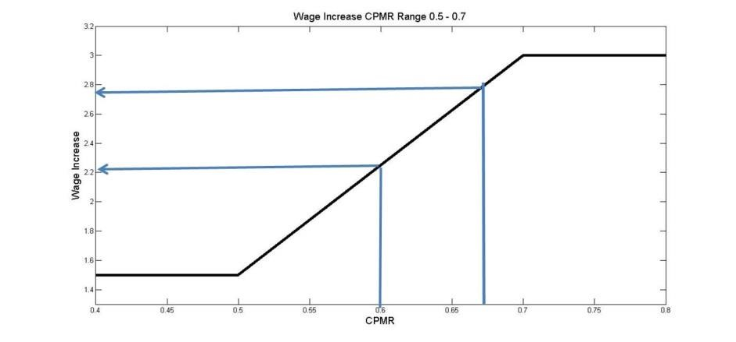

For purposes of these examples the EAGWI Multiplier is set at 3.00%:
Example 1. CPMR = 0.6 and EAGWI = 2.00; with CPMR of 0.6, the calculated wage increase = 2.25% (off chart/calculator); however the EAGWI of 2.00<2.25 then the member will receive 2.00% wage increase.

Example 2. CPMR = 0.675 and EAGWI = 3.50; with CPMR of 0.675, the calculated wage increase = 2.75% (off chart/calculator); thus 2.75% <EAGWI then member will receive 2.75% wage increase.

II. Determination of merit multiplier for Clinical Merit relative to CPMR or Revenue/Salary ratio.

- Graphic representation of merit multiplier using CPMR value. Note: with CPMR below 0.8 merit multiplier = 0, CPMR at 0.8 then merit multiplier = 0.5; CPMR at or above 3.0 then merit multiplier = 3.0, CPMR between 0.8 and 3.0 is determined from the equation: merit multiplier (CPMR) = [0.5 + (CPMR-0.8)(2.5/2.2)] (see graphic representation and examples below).

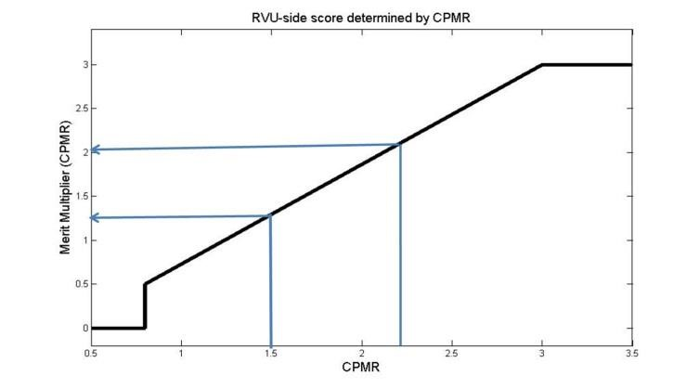

Example 1. CPMR = 1.5; Merit Multiplier (CPMR) = [0.5 + (1.5-0.8)(1.1364)] = 0.5 + 0.7955 = 1.2955

Example 2. CPMR = 2.2; Merit Multiplier (CPMR) = [0.5 + (2.2-0.8)(1.1364)] = 0.5 + 1.5910 = 2.091

OR: Merit multiplier based upon Revenue/Salary is used if higher than merit multiplier (CPMR)

- Graphic representation of merit multiplier for Revenue/Salary ratio, merit multiplier (R/S). Note: Rev/Sal at 2.2 = merit multiplier of 0.5, and Rev/Sal ratio of 4.0 = merit multiplier of 3.0, Rev/Sal above 4.0 = merit multiplier of 3.0. Rev/Sal ratio between 2.2 and 4.0 is determined by the equation: merit multiplier (R/S) = [0.5 = (Rev/Sal-2.2)(2.5/1.8)] (see graphic representation and examples below).

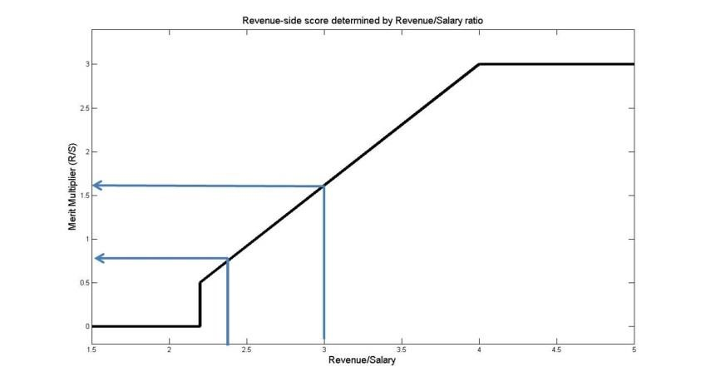

Example 1: Rev/Sal = 2.4, CPMR = 1.5 (merit multiplier (CPMR) = 1.2955, above) then merit multiplier (R/S) = [0.5 + (2.4-2.2)(1.3889)] = 0.7778: merit multiplier (CPMR) is used since 1.2955> 0.7778.

Example 2: Rev/Sal = 3.0, CPMR = 2.2 (merit multiplier (CPMR) = 2.091 above) then merit multiplier (R/S) = [0.5 + (3.0-2.2)(1.3889)] = 1.6111: merit multiplier (CPMR) is used since 2.091>1.6111.

ATTACHMENT C – MOA SODM Executive Council for Faculty Merit Review

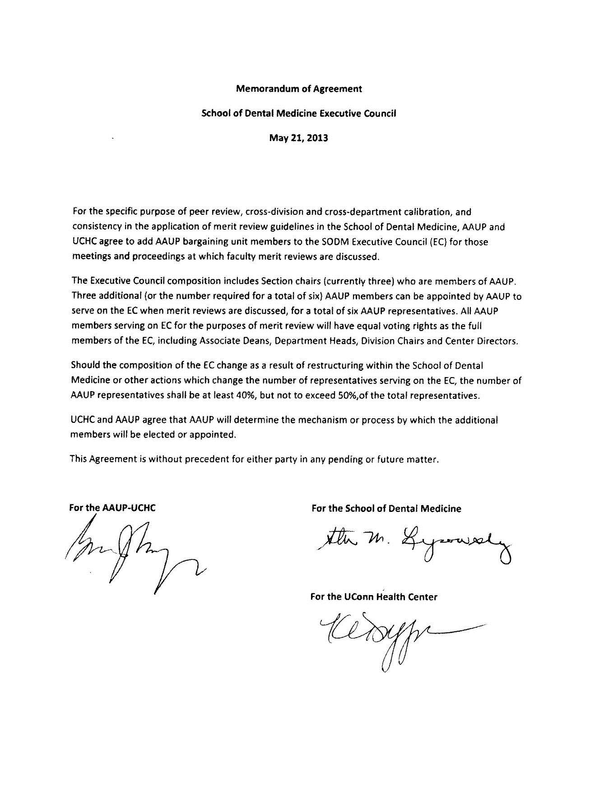

ATTACHMENT D

Summary of Provisions of the Faculty Merit Plan (FMP) and the Alternative Bonus Plan (ABP)

All faculty members will participate in the Faculty Merit Plan or the Alternative Bonus Plan, but not both.

Faculty Merit Plan (FMP)
- The FMP is the default merit plan for all bargaining unit faculty who are not offered an ABP (or not grandparented on an individual compensation agreement).
- FMP metrics were negotiated by AAUP and UCH and are not individualized.
- Faculty can earn merit payments based on their performance in the clinical and/or academic domains.
- Faculty must have an aggregate academic merit review rating of acceptable or above to participate.
- Payments are drawn from the negotiated distribution pool that also funds general wage and equity increases.
- It is not possible to know in advance the exact value of a merit payment for an individual faculty member because the payment depends on the total number of faculty receiving merit payments.
- Each faculty member’s salary is mapped to national professional salary tables. Merit payments are added to base salary up to the median salary for the faculty member’s rank and mapped specialty, and any amounts over that figure are paid as one lump sum early in each new fiscal year per the agreement.
- Faculty on the FMP are eligible for general wage and equity increases.

Alternative Bonus Plan (ABP)
- ABPs are offered to specific faculty members and new hires at the discretion of the Health Center.
- Individual performance targets are described for the faculty member that are specific, observable and measurable.
- Faculty earn specific payments if performance targets are met.
- ABP payments are not added to base salary but are paid as a lump sum.
- ABP payments are not funded from the negotiated distribution pool.
- Faculty on the ABP may qualify for general wage and equity increases based on their annual clinical and academic reviews.
- Acceptance of an ABP offer is voluntary. If declined, the base salary offer will not change, and the faculty member will participate in the FMP.
AAUP contact information: Susan Hunt, AAUP Office Administrator, 860-678-0826, shunt2468@gmail.com.

My signature below is testament that I have read this document and understand that if I accept the offered ABP, I will not participate in the FMP, for the term of the ABP.

Faculty name Date

ATTACHMENT E – REVISED AND APPROVED 9/10/13 AND 9/6/17

Compensation section for ABPs

Your annualized base salary will be $X and if you are part-time, will be pro-rated according to percent of time employed. Your salary is payable in accordance with the UCH’s payroll policies in bi-weekly installments. Changes in base salary will be made according to the AAUP/UCH agreement.

You may receive an Equity Adjusted General Wage Increase (EAGWI) to your base salary according to the AAUP/UCH agreement. Such increases are possible according to the terms of the collective bargaining agreement. These increases are contingent on a review of annual clinical and academic activities.

The Alternative Bonus Plan (ABP) described below will be the sole mechanism to determine you merit payments for the term of this contract.

All bullets below must be included. They can be combined into a paragraph rather than a bullet list if appropriate. Footnotes 1 & 2 are informational to the letter writer. Footnote 3 is to be included in the letter (and will remember itself appropriately).

- The metric(s) that will be measured to determine your merit payment(s) is/are .
- Your (insert name of metric(s)) target is (this target must be a specific number or specific formula). This target has been determined by…(e.g. 2.2 times salary and fringe; or RVU tables published by X for year X, etc. If a published metric such as RVUs, state the publication date and which part of the table is used. State if the targets relate to just a portion of work effort such as the clinical effort, or the entire work effort.)
- Your initial (insert name of metric(s)) review will consider the metrics earned from date x to date y. State the dates of subsequent review periods.
- (include first phrase only if appropriate) Because it takes time for all the data to be collected, your initial
(insert name of metric) review will occur in the month of and subsequent reviews will occur in the months of .
- Following each review, if you have achieved the target, then you will be paid a lump sum in the amount of $X, or calculated as follows:
- This/these payment(s) do not become part of your base salary.
- Payments will be included in a paycheck received about one month after the review is conducted.

To be included in letters with terms extending beyond June 30, 2021.
ABP payments beyond June 30, 2021 are subject to terms of the UCH-AAUP contract.

Example 1 for a letter with a term of Sept. 1, 2013 to June 30, 2015:

The metric that will be measured to determine your merit payments is “collected revenue,” defined as revenues collected for your clinical activity.
- Your collected revenue target is 2.2 times your clinical salary and fringe benefits. During your initial review period, while your salary is $, this figure of 2.2 times salary and fringe is $Y.
- Your initial collected revenue review will consider the collected revenue earned from September 1, 2013 to March 31, 2014. Your second review will consider collected revenues earned from April 1, 2014 to March 31, 2015. Your final review will consider collected revenues earned in the period April 1, 2015 to June 30, 2015.
- Because it takes time for all the data to be collected, your initial collected revenue review will occur in the month of May 2014 and subsequent reviews will occur in the months of May 2015 and August 2015.
- Following each review, if you have achieved the collected revenue target, then you will be paid a lump sum of $X.
- These payments do not become part of your base salary.
- Payments will be included in a paycheck received about one month after the review is conducted.

Example 2 for a letter with a term of Sept 1, 2013 to June 30, 2015

You will participate in an Alternative Bonus Plan (ABP) as described below for the entire term of this contract.
- The metric that will be measured to determine your merit payments is physician work relative value units, or wRVUs. wRVus are a method for determining the value of a physician service, and take into consideration the time, technical skill and effort, mental effort and judgment, and stress, required to provide a clinical service. wRVUs are determined by the Centers for Medicare and Medicaid Services (CMS).
- Your RVU target is 80% of the median wRVUs for your specialty and percent clinical effort. At the present time, the median for a full time clinician in your specialty is 8000. Your initial clinical allocation of effort is 70%. 70% of the full time median is 5600, and 80% of the median for 70% effort is 4480. This is your initial annual target. It will be revised if your clinical effort changes, and if CMS publishes revised data tables.
- Your RVU reviews will occur quarterly except that your first review period will cover 4 months to accommodate a start date in the middle of a quarter. Your initial RVU review will consider wRVUs earned from September 1, 2013 to December 31, 2013. Subsequent reviews will cover the periods of Jan-March, April to June, July – September, and October-December. Your final review will consider wRVUs earned in the period April 1, 2015 to June 30, 2015.
- Because it takes time for all the data to be collected, your initial RVU review will occur in the month of February 2014 and subsequent reviews will occur 6-8 weeks following the end of each review period.
- Following each review, if you have achieved the RVU target, then you will be paid $37 for each wRVU earned above the target. Thus, unless your clinical effort or the published RVU tables change, you will be paid $37 for each RVU earned above the annual target of 4480 or quarterly target of 1120.
- These payments do not become part of your base salary.
- Payments will be included in a paycheck received about one month after the review is conducted.

ATTACHMENT F

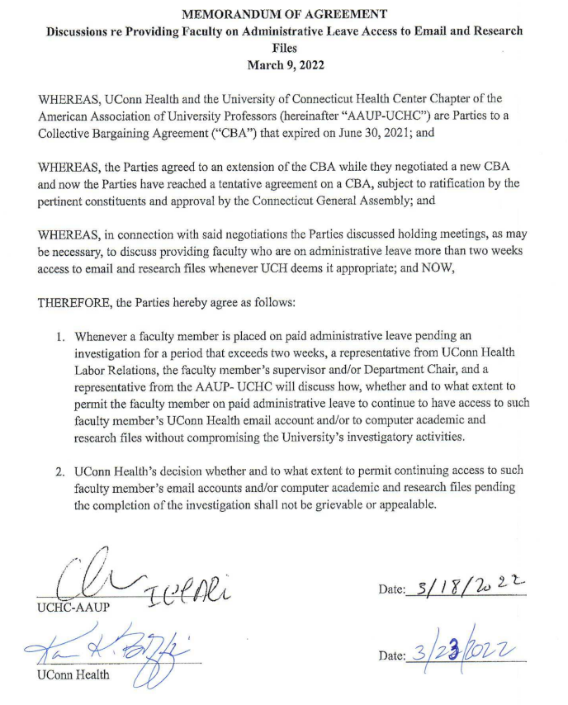

ATTACHMENT G
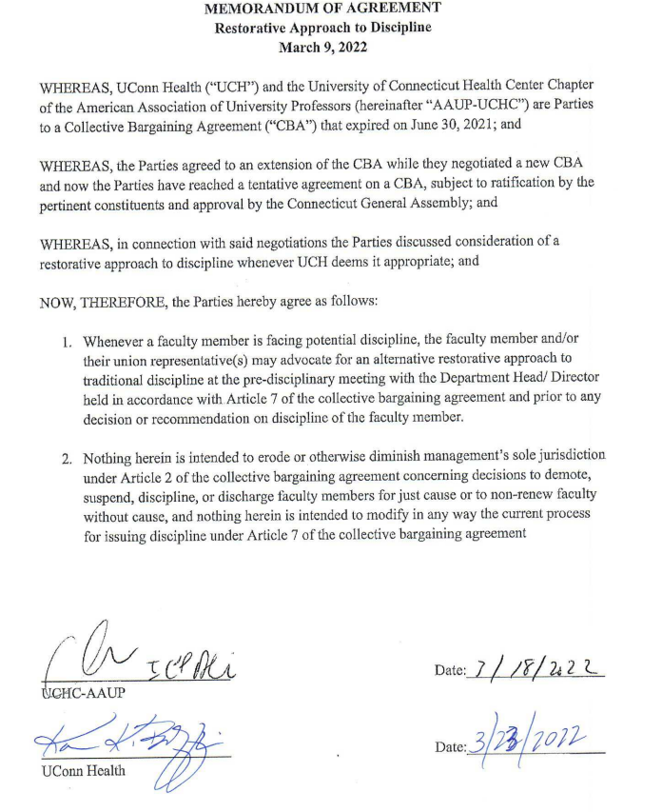

Not included in this document:

- Side letter on suspension of “Good Standing” under Faculty Merit Plan during term of this CBA;
- Side letter on addressing block hospitalist issues by July 1, 2022.

By-Laws sections referenced are titled "Termination of Appointments by the Institution," "Dismissal Procedures," "Suspensions," "Terminal Salary," and "Health Center Faculty Grievance Procedures."
This is the definition of bSalary for calculations of EAGWI and Merit only.
SOM faculty with less than .5 FTE, who have not been required to undergo an annual merit review, will be considered to have received an “acceptable” score for aMerit.
Has the educational training and is eligible to practice that specialty in accordance with CT licensure regulations.
Faculty who provide clinical services to patients which are billable through UMG, JDH or a clinical service contract.
Any and all metrics used must be specific, observable and measurable, and not subject to the judgment of an individual. If “citizenship” variables are used, they must also be specific, observable and measurable. Metrics should be variables that are relevant, could be collected for faculty in similar positions, and are related to their job description. Examples of metrics are revenues earned, RVUs, PressGaney scores, salary support on grants, and indirect grant dollars brought to the Health Center.
Data can be reviewed on a quarterly basis or annually, but the end day of an “annual” review will be March 31. This is to synchronize the review with those occurring for faculty in the Faculty Merit Plan since both groups receive EAGWIs and clinical productivity affects the EAGWI.
March 31 is the “snapshot date” used to calculate EAGWIs.

