UCHC-AAUP NEWS
Chapter Newsletter
Volume I, No. 4 Fall 2015

Bargaining Update  On October 22nd negotiations kicked off on the new 2016 collective bargaining agreement. Thank you to all of those whom participated in our bargaining unit survey. You identified several key concerns, which included augmented salary, sufficient time to complete electronic medical records, and better protected academic time. We look forward to working with the administration to productively to enhance your work life.  Multi-Year Appointment Agreement Reached  Recently, we reached agreement with the administration regarding multi-year appointments. As of this writing, in-resident faculty will be eligible for two-year appointments assuming they meet certain clinical and academic targets. Further, we secured an April 1st deadline, so that all faculty will be notified of their prospective appointments for the new fiscal year by this date.  FOLLOW  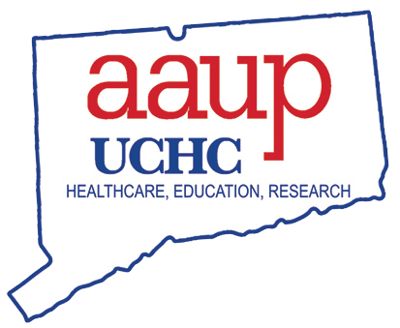  ONLINE FOR MORE UPDATES!  Website:  http://uchc-aaup.org/ | 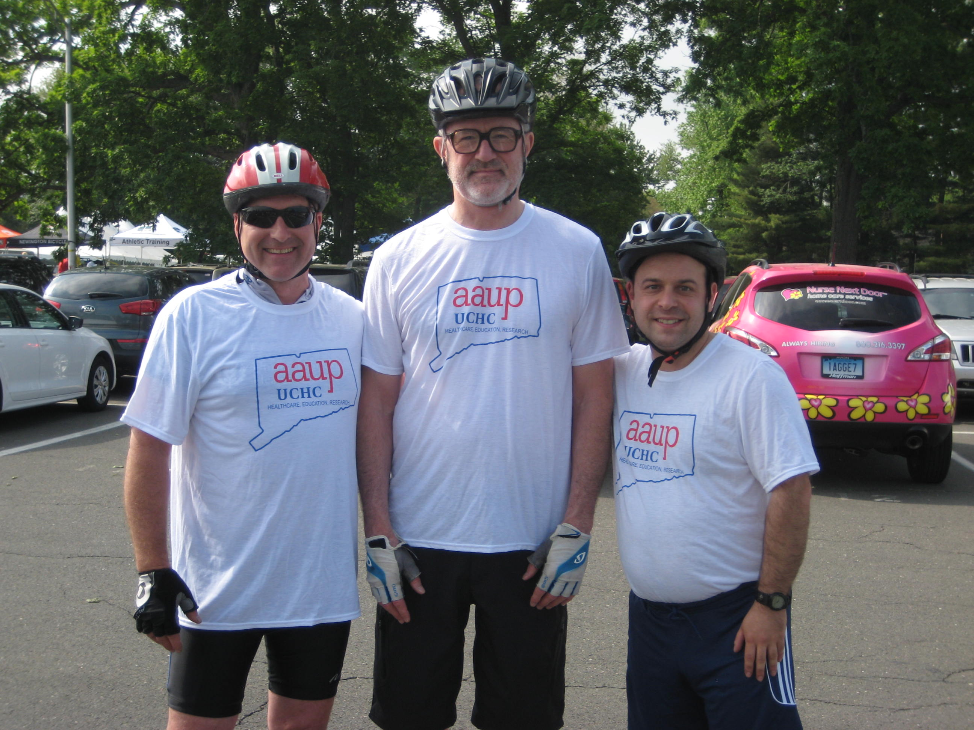  UCHC-AAUP Participates in 2015 Jim Calhoun Ride and Walk  Recently, the UCHC-AAUP took part in the annual Jim Calhoun Ride and Walk for Life Saving Research and Care to raise money for UCONN Health. We are delighted to have sponsored four faculty members, John Carson, Kevin Claffey, Ann Cowan, and Stephen Schensul. Two members of the team completed the 30-mile challenge, while the remaining members took on the 15-mile route. UCHC-AAUP Executive Director, Diomedes Tsitouras also joined the 15-mile team. It was a successful and adventurous day! We are pleased to do our part for the UCONN Health community and look forward to do so again in the future.
Creative Childcare Center
Stays Open

Recently, members of the UCONN Health administration have proposed closure of UCONN Health’s childcare center. We were taken back by that, as this entity is the sole option for many faculty families. We were unequivocal in our opposition to the closure. We are pleased to report now that the Executive Vice-President of Health, Dr. Andrew Agwunobi has publically committed to keeping this facility open.
For over 20 years, the Creative Child Care Center has provided a safe, caring, and rich educational environment for children 8-weeks old to 5-years old. It is strongly committed to the goal of making children and parents feel that the center is an extension of their family life. Accredited by the National Association for the Education of Young Children (NAEYC), and equipped with a fully qualified staff, it is competitive in both price and quality with any local alternative.
While we are pleased that there are no closure plans, several faculty members have expressed concerns about the status of the building, which is quickly aging. We share this sentiment and are working on finding a viable solution.
If you are interested in enrolling your child, you may contact Tonie Matthews at (860) 679-2124 or see http://employ.uchc.edu/childcare/index.html for more information.

Parking
We remain committed to rectifying the parking situation. We regularly express your concerns at our monthly LRMC meetings and will continue to remain assertive.

AAUP joins amicus brief on teacher protections  AAUP National joined in an amicus brief in the California Court of Appeal contesting a ruling by a California state court judge that found that California statutes providing tenure protections to K–12 teachers violated the equal protection provisions of the California constitution. The case arose from a challenge, funded by anti-union organizations, to five California statutes that provide primary and secondary school teachers a two-year probationary period, stipulate procedural protections for non-probationary teachers facing termination, and emphasize teacher seniority in reductions of force. The trial court judge held that the statutes unconstitutionally impact students’ constitutional right to equality of education and disproportionately burden poor and minority students. The amicus brief contesting this decision argued that the challenged statutes help protect teachers from retaliation, help keep good teachers in the classroom by promoting teacher longevity and discouraging teacher turnover, and allow teachers to act in students’ interests in presenting curricular material and advocating for students within the school system.  http://www.aaup.org/brief/vergara-et-al-v-state-california-et-al-and-california-teachers-association-and-california | Long-Term Disability Win  Starting January 2014, UCONN Health decided to downgrade its long-term disability benefits afforded to faculty and other UCONN Health employees. This included a decrease in the maximum monthly from $8,000 to $6,000 as well an elimination of the annual cost of living adjustment (COLA).  Under Connecticut state law, the UCONN Health Administration must negotiate any changes to the terms and conditions of employment of bargaining unit members prior to instituting any change. Because it failed to give the union notice and an opportunity to bargain over this change, and instead acted unilaterally, it was in breach of this requirement.  The UCHC-AAUP and UHP, AFT Local 3837 promptly filed charges with the State Labor Board. Before the matter was officially heard, UCONN Health administration agreed to settle the matter with the unions by agreeing to make faculty members and UHP employees whole for the difference in benefits. The parties also agreed to resolve the fate of the LTD program in the 2016 collective bargaining agreement negotiation. We look forward to engaging in this conversation and finding a solution that is both financially responsible and takes care of UCONN Health’s most vulnerable employees.

WHY MEMBERSHIP MATTERS  Almost 75% of the UCHC-AAUP faculty are union members. Membership allows you to have a say in how decisions are made. These include voting on your collective bargaining agreement, electing chapter and national AAUP officers. Because Connecticut is a “union shop” bargaining unit members are assessed an “agency fee” (non-members) or “union dues” (members), which is automatically deducted from pay. Because these amounts are the same, it makes sense for faculty members to join the chapter so that their voice is heard in union decision-making.  Several years ago, we were founded on the idea of promoting the highest standards of excellence in education, research, clinical care, while simultaneously maintaining a fair and equitable workplace. Since then, we have been an independent resource and advocate for several of your colleagues wrongfully treated. We have recovered fees erroneously charged and kept the administration accountable on countless issues such as discipline, promotion, and post-tenure review. We have also worked cooperatively pushing for more NIH funding and for UCONN as a whole.  Still, we are not satisfied. We endeavor to do more. In our upcoming negotiation, we will propose contract articles to address parking, the endless time spent on electronic recordkeeping, professional development reimbursement, and gender equity to name just a few. Everyone’s voice is critical to this effort.  In order to join UCHC-AAUP, a faculty member must sign a membership form, which may be found on the website (uchc-aaup.org). If a faculty member is unsure if he/she is a member, please call Susan in the UCHC-AAUP office. | AAUP STAFF  EXECUTIVE DIRECTOR  Diomedes Tsitouras  OFFICE MANAGER  Susan Hunt  860-678-0826  Fax: 860-678-0832  AAUP E-MAIL: uchcaaup12@gmail.com  2015-2016  EXECUTIVE COUNCIL  Officers  President – Santhanam Lakshminarayanan, Medicine  Vice President – Joseph Palmisano, Medicine  Secretary/Treasurer – Ann Cowan, CCAM  Members  John Carson, Medical/Basic, CCAM  Kevin Claffey, At-large, Cell Biology  Kourosh Parham, Medical/Clinical, ENT  Bruce Mayer, At-large, Genetics and Genome Science  Aditya Tadinada, Dental, Oral Health and Diagnostic Sciences  Effie Ioannidou Dental, Oral Health and Diagnostic Sciences  Les Bernstein, Medical/Basic, Neuroscience  Amir Nasir, Medical/Clinical, Surgery

